The Design Process Before Prototype 1

During the first week, I have tried to brainstorm various VR application scripts. In contrast to the current architectural design applications, I have also imagined VR painting since the examples in the lecture slides seemed to be painting VR apps. In addition to this, the topic we chose for the studio discussion was social apps, which I also documented and did some designing of interactions afterwards.

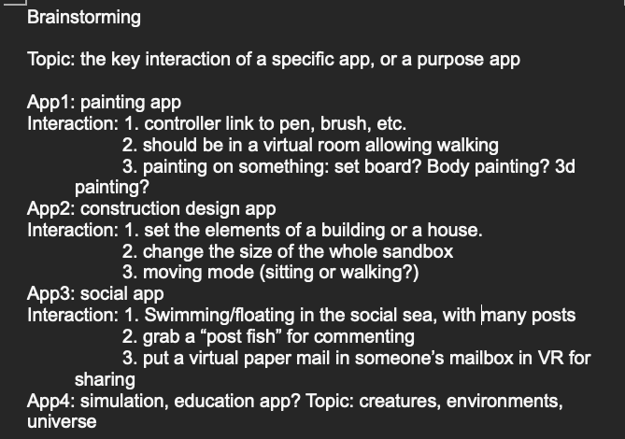
Fig x: The note I have created for recording the brainstorming.

After that, I tried to prepare some very quick and simple concept sketches for each idea, which I drew myself. They don't serve as storyboards or formal design solutions, but they make it easier for me to explain my direction to others.

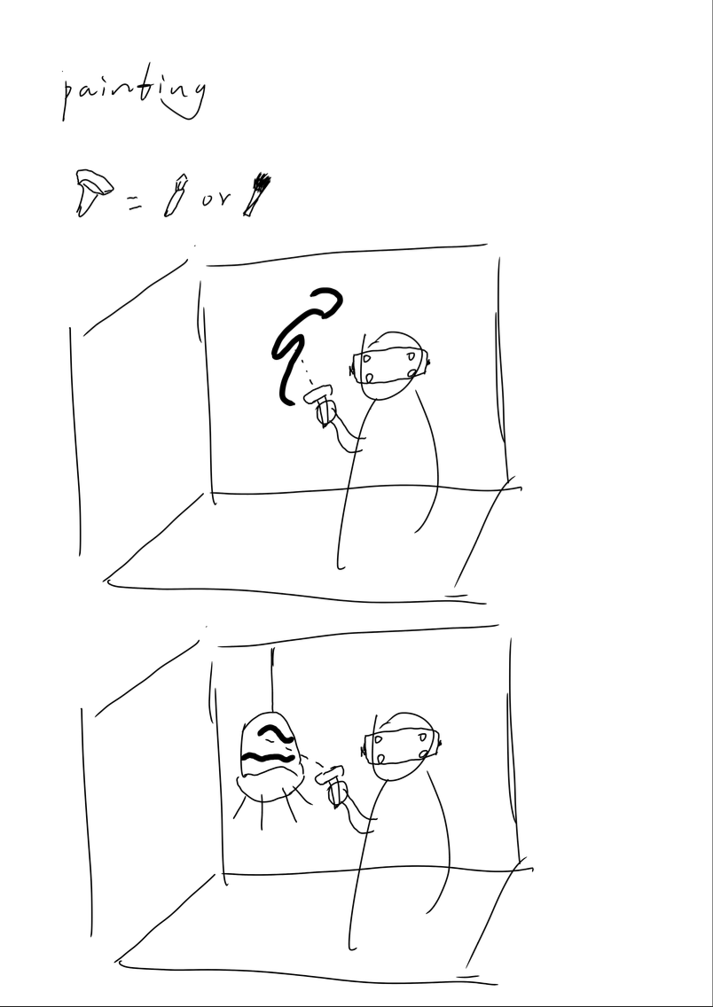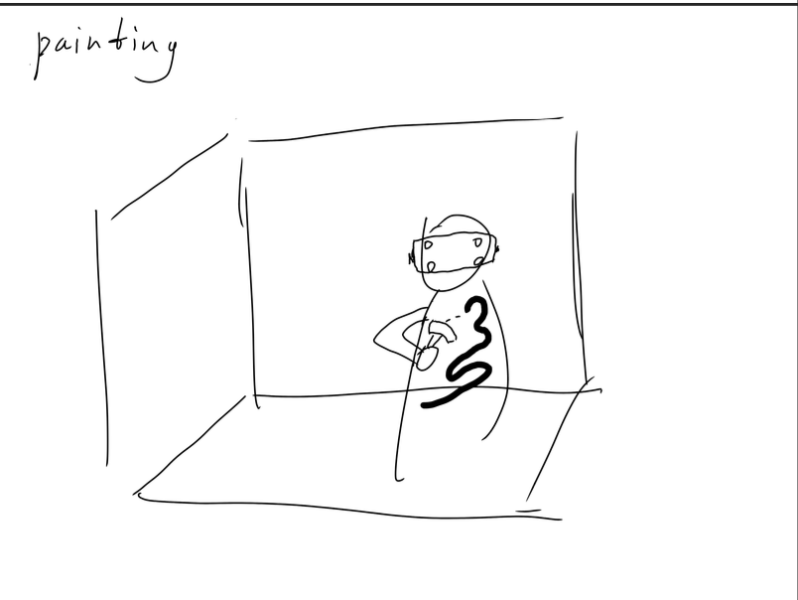
Fig x: The draft of the VR painting app. The major interaction is painting on the surface of the object in the real world or the user’s body.

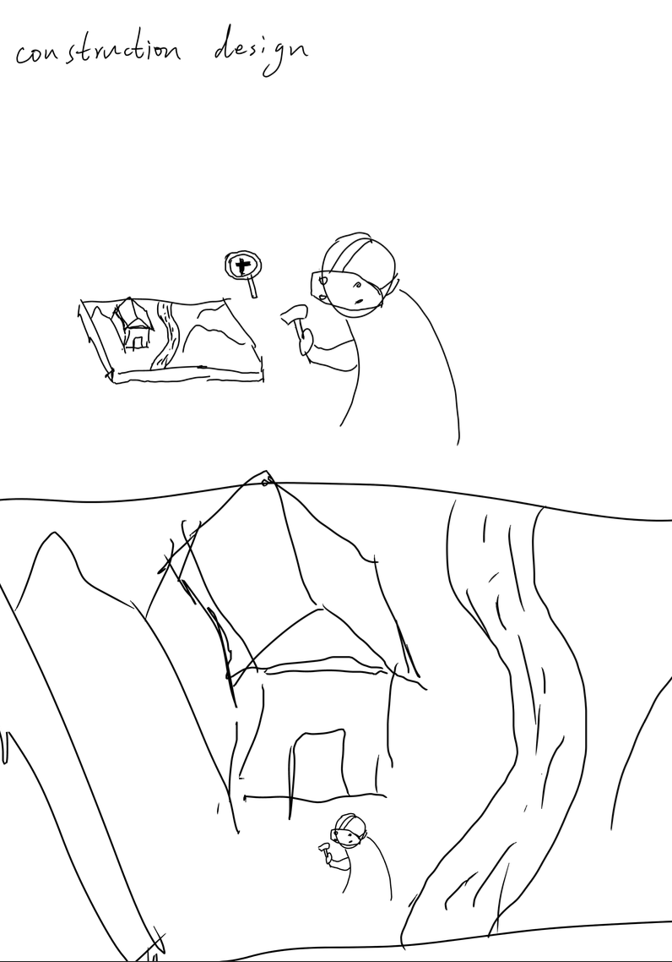
Fig x: The draft of the construction design app. The major interaction is zooming.

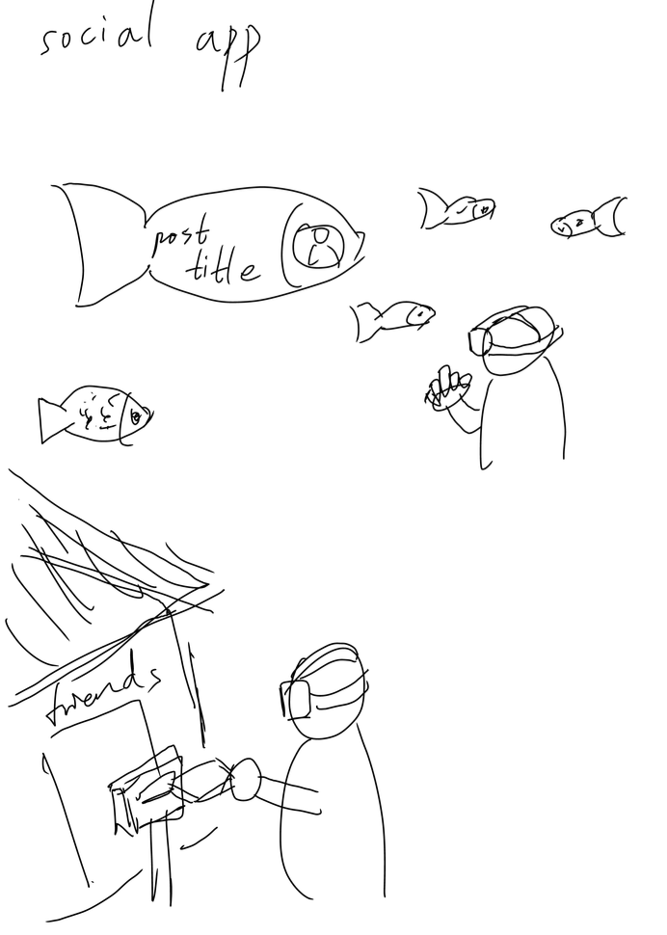
Fig x: The draft of the VR social app. The major interaction is browsing posts and messaging friends.

After preparing enough options for ideas, I did seek the opinions of different tutors. They generally agreed that all of my ideas were pretty suitable and whichever one I chose as the direction to go after would be fine. At the same time, they also provided some interesting ideas, such as innovations in the way users interact in the social app, and some improvements to the architectural design app.

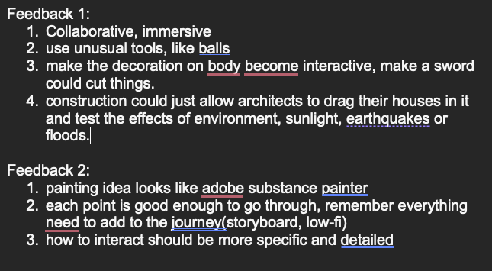
Fig x: The note of tutors’ feedback.

In the end, I chose the architectural design app because I wasn't sure if drawing would fulfil the requirement for innovative interactions. I don't feel like I got a very interesting way of interacting with drawing, but the way of combining architectural sandboxes and immersive experiences in user interaction was very appealing to me.

After deciding on a general direction, I started trying to visualize the tasks and make a storyboard. I want the user to be able to zoom in and out of the entire architectural sandbox with a simple gesture. When the user is confronted with the reduced model, they can easily design and adjust elements such as the building's position and lighting. After completing the design they want, the user only needs to zoom in on the entire virtual reality with a gesture, and they can have an immersive experience of what the design they just created would look like in reality.

On top of that, users should have enough space to move in reality so that they can view the sandbox from all angles and explore the building in an immersive situation. For the adjustment of some environmental elements, such as lighting and wind direction, the app will also provide appropriate gesture interactions to achieve this.

Overall, the key is to use gesture interaction and body interaction to achieve a combination of immersive experience and architectural design. Hence, the three tasks will be these:
- the adjustment of the angle of daylight exposure
- the adjustment of the scale zooms
- the movement of the designer

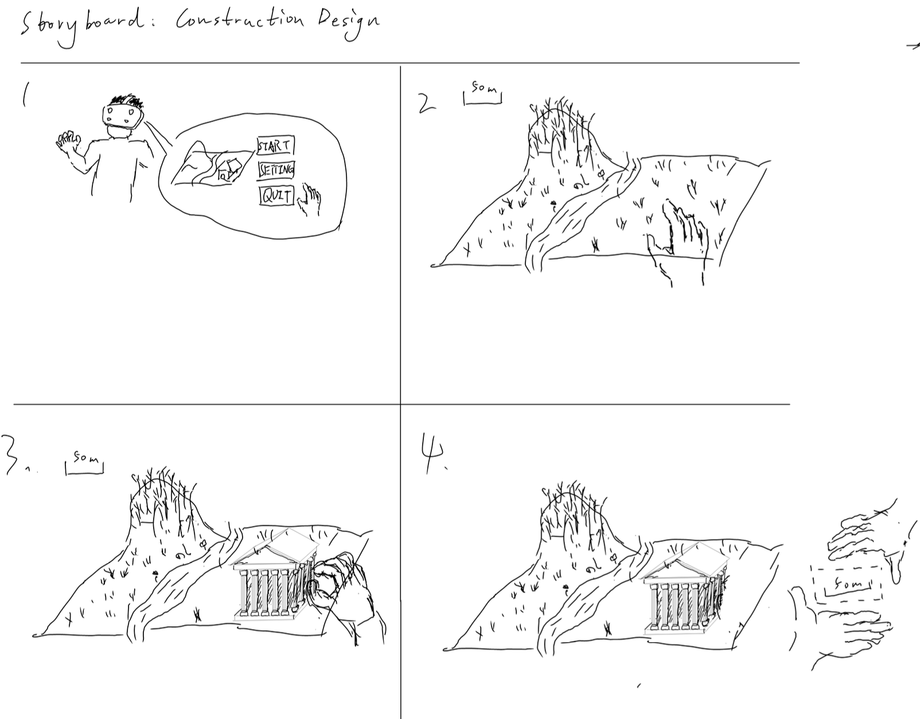
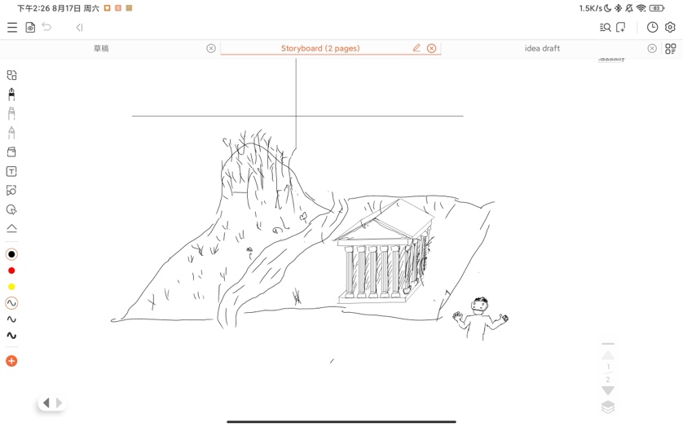
Fig x: The storyboard of zooming interaction.

After the tutor had a look at my storyboard in the next studio, he thought it was an interesting interaction, but obviously not well suited for paper prototype testing. So I turned to another interaction that was more suited to paper modelling.

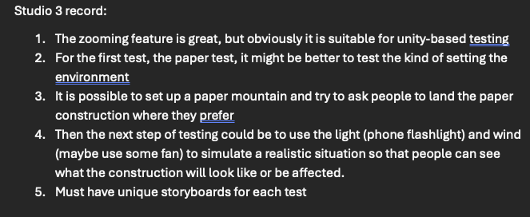
Fig x: The note of zooming interaction and related storyboard.

In my view, an interaction suitable for paper models should be something that can interact with gestures, and also the purpose of the test shouldn't be demanding of the immersive experience but rather focused on experiencing and collecting data on the paper product on the table. An interaction that I believe could fit the above description is that adjustment for environmental elements. Therefore, I designed storyboards for light adjustments that contain my design for how the user adjusts to sunlight. One is to move the terrain itself to make adjustments, and the other provides a board to make adjustments. The difference will be the main purpose of exploration later during studio testing.

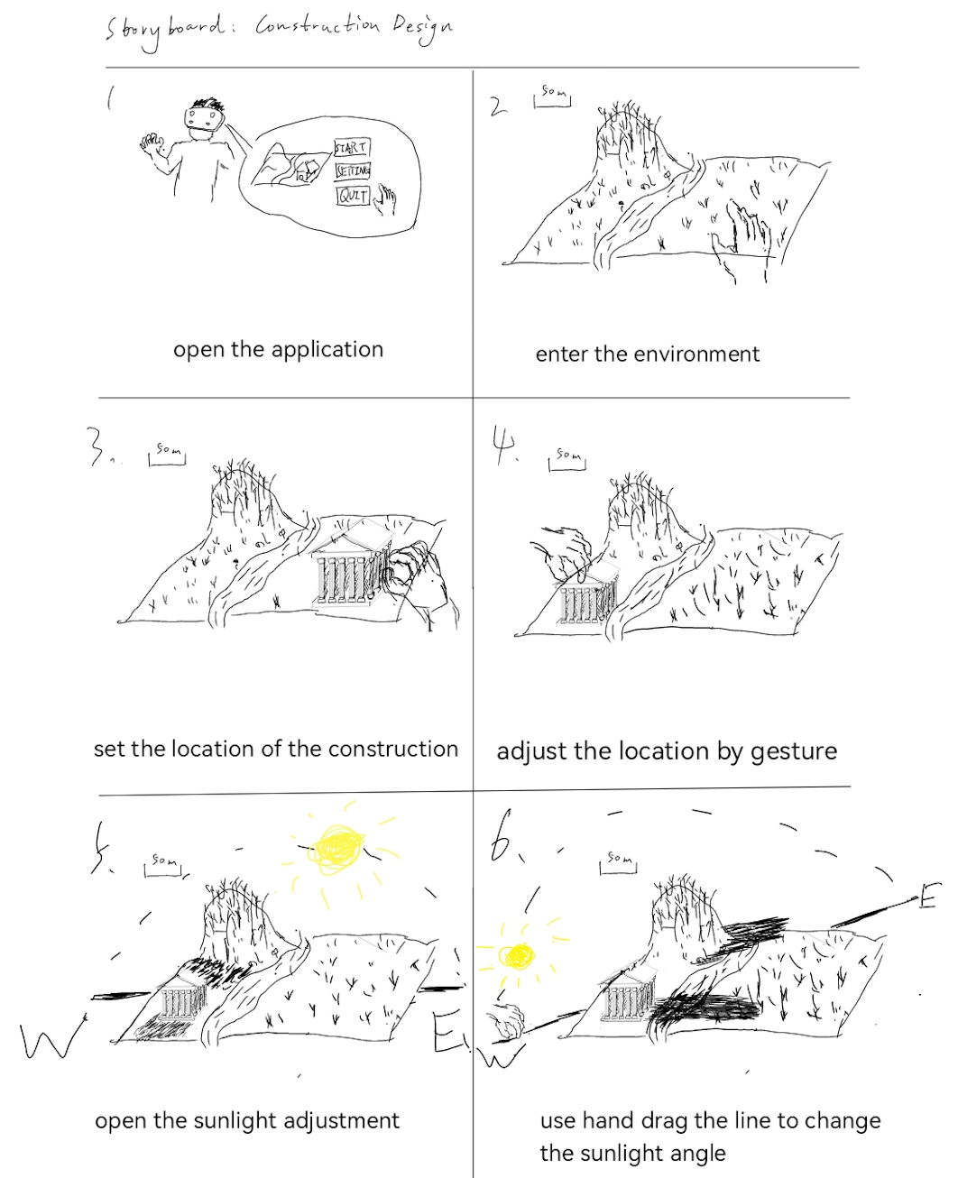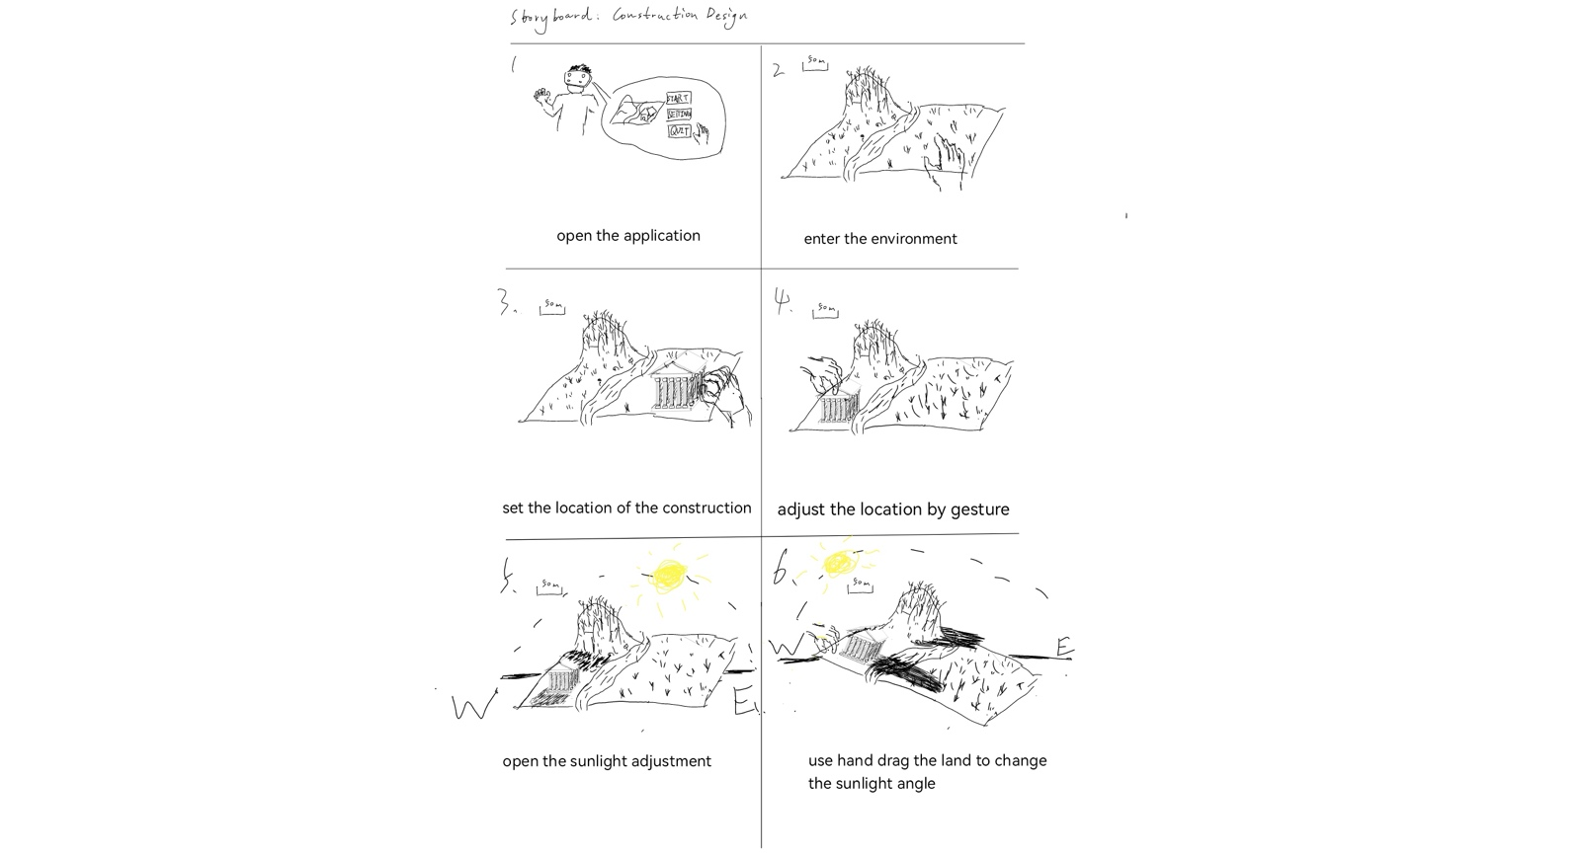
Fig x: The storyboards of sunlight adjustment.

